SEND Report to Governors Holybrook Primary School
2020-21

The purpose of our school’s SEN Information report is to inform parents and carers about:
● How we welcome into our school children with special educational needs and/or disabilities;
● How we support them in all aspects of school life and remove barriers to achievement;
● How we work in closer partnership with parents/carers and children;
● How we make effective provision for all of our children with special educational needs and disabilities - SENDD

SEND at Holybrook Primary School
This is a breakdown, year group by year group, of the numbers of pupils on our SEND register.
Year group | Number of children in class | Number of children on SEND register | Below Age Related Expectations | SEND Support | EHCNA agreed but plan not finalised | EHCP  In place
Nursery | 35 | 7 | 5 | 2 |  | 0
Reception | 30 | 8 | 4 | 1 | 1 | 2
Year 1 | 29 | 8 | 5 |  |  | 0
Year 2 | 27 | 6 | 4 | 1 |  | 1
Year 3 | 29 | 6 | 4 |  | 1 | 1
Year 3 Horizons | 1 | 1 |  |  |  | 1
Year 4 | 31 | 7 | 4 | 1 |  | 2
Year 4 Horizons | 2 | 2 |  |  |  | 2
Year 5 | 26 | 9 | 7 |  |  | 2
Year 5 Horizons | 3 | 3 |  |  |  | 3
Year 6 | 26 | 9 | 8 | 1 |  | 0
Year 6 Horizons | 2 | 2 |  |  |  | 2
Total | 241 | 68 | 41 | 6 | 2 | 16

Budget and finance
As a school we receive the school budget from the Education Funding Agency. This includes the Notional SEN budget to support SEND children. This budget (£175,255 in 2020-21) was used to support SEND children with all levels of need. Up to £10,000 (£4,000 from the normal school budget and £6,000 from the Notional SEND budget – equivalent to 19+ hours 1:1 support per week) must be spent by school to support a child with SEND before applying for extra funding through the EHCP process. In 2021-22, the budget is expected to be higher, at £190,808 as a result of having higher numbers of children with SEND on roll.
The way the SEND budget is spent is decided upon by the Head of School and SENDCo in discussion with the governors. If the child has educational needs beyond ‘School Support’, extra funding (on top of this £10,000) can be applied for. Bradford’s SEND Services will determine the amount of the additional funding. This will be based upon evidence provided by parents/carers, the child or young person, the school and other professionals. The additional funding is allocated through an Education, Health and Care Plan (EHCP).
As of June 2021, our high needs block of funding is £95,374, up from £24,554 last year. This increase reflects the significantly higher number of pupils with EHCPs across the school including the Horizons Resourced Provision. This funding has been allocated to support children with Education and Health Care Plans across both the mainstream school and the resourced provision.
Our response to Covid 19
At Holybrook Primary School we are proud of our response to the emotional well-being of our school community during the Covid-19 pandemic. The school has been open throughout to vulnerable and key worker children/ all children with SEND. As well as online teaching, we have ensured that all families have been contacted by a member of staff regularly. We have worked to ensure that families receive the necessary support whether that be food parcels, signposting to local services or dedicated email address monitored by key staff members. As children have returned to school we recognise that all of the school community have experienced change and for some, trauma. Consequently, all staff have undertaken training in the Zones of Regulation, with key staff undertaking other well-being training.
Our recovery curriculum allows for children to talk through their experiences during lockdown and subsequent worries and concerns so that they are in a place where they are able to learn. We recognise that some of our children have thrived whilst being at home and spending more time with their families whilst others have found this more challenging. We are mindful that some children will have slipped in their learning and our curriculum is tailored to ensure children move forwards with their learning.
Approach to teaching and adaptation of curriculum and environment
Class teachers plan lessons and differentiate according to the needs of children in their class. Sometimes this means simplifying a task, arranging alternative methods of recording, providing additional equipment or resources, grouping children carefully, and/or deploying support staff to give extra help. A child may also benefit from personalised programmes delivered in a small group, a pair, or on an individual basis.
All children who have additional needs are recorded on a class provision map. We have also recorded our response to the Covid 19 pandemic, identifying how our pupils, including SEND pupils, have had additional support since returning to school. Personal Learning Plans (PLPs) are used to write targets for children who are at ‘school support’. A breakdown of how Holybrook can meet each different area of need (including approach to teaching, adaptation or curriculum and provision) at each range, can be found in our Local Offer on the school website.
SEND Local Offer | Holybrook Primary School (holybrookacademy.co.uk)

Example Personal Learning Plan (PLP)

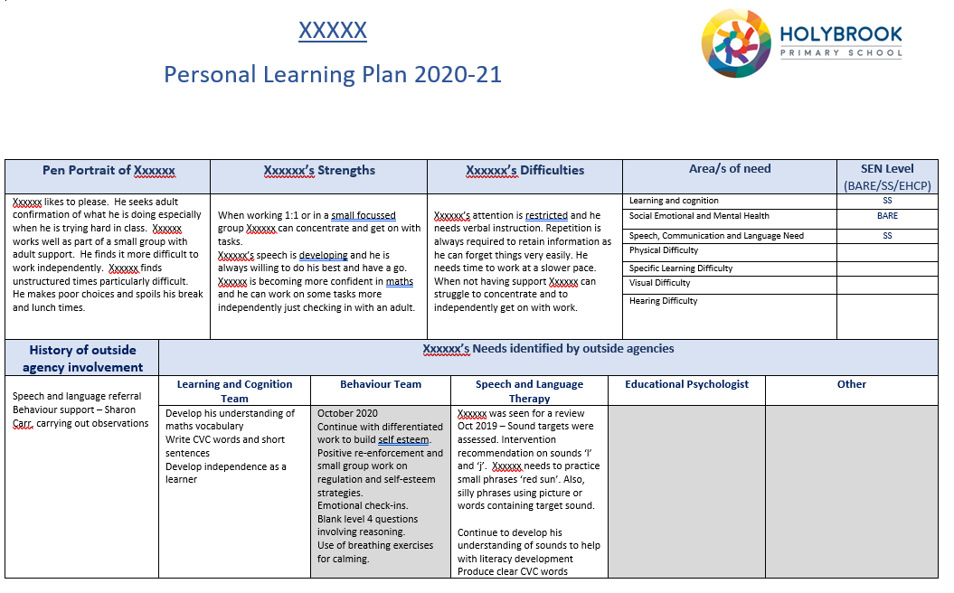

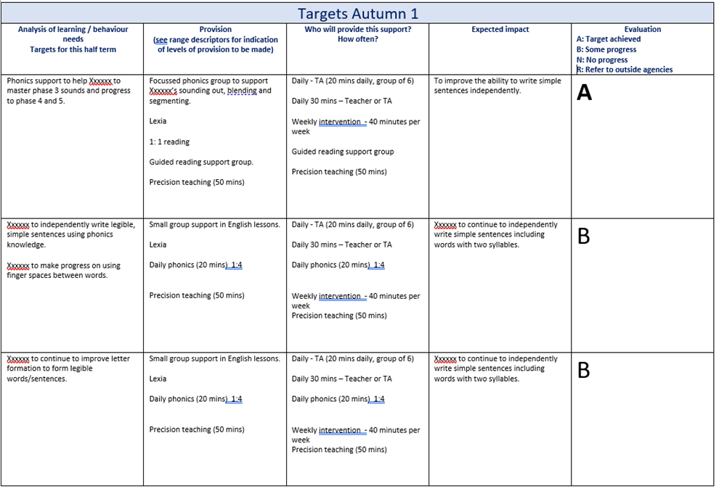

Example Provision Map
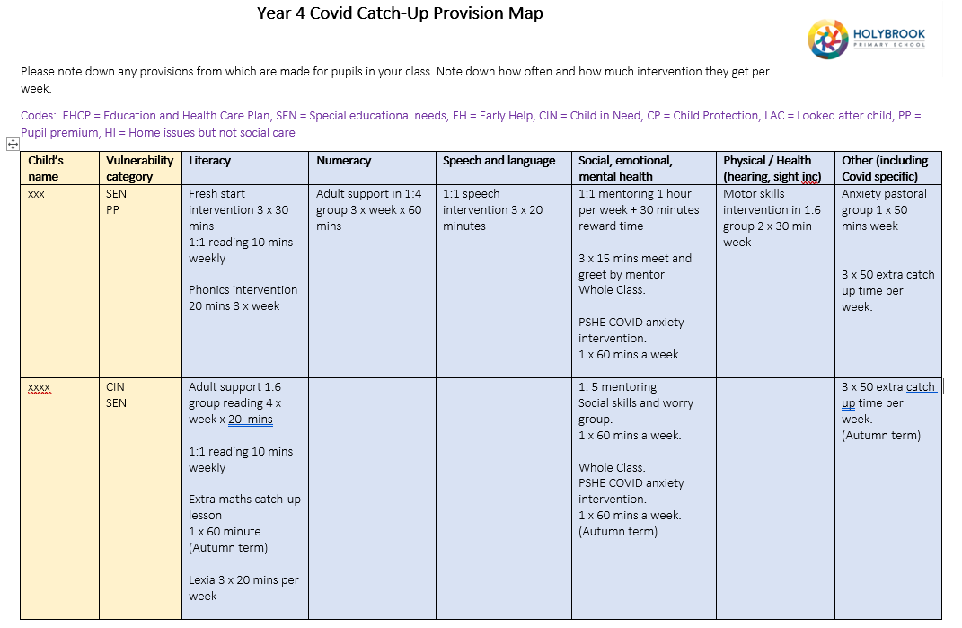
Identification of SEND
To identify pupils with SEND, Holybrook Primary will:
- Look at current assessment of the pupil or attainment on entry
- Look at any information provided by previous setting, parents or involved agency
- Use regular teacher assessment to monitor progress
- Look at the progress in comparison the peers
- Speak to parents and the pupil about their views
- Seek advice from external agencies where appropriate

We will the monitor curriculum interventions carefully to ensure that:
- the child’s progress is similar to that of their peers starting from the same baseline
- progress matches or betters the child’s previous rate of progress
- the attainment gap between the child and their peers is closing
- we prevent the attainment gap growing wider
- The school will provide extra support to pupils falling behind or making inadequate progress given their age and starting point and if necessary, re-assess a pupil’s learning need where pupils continue to make inadequate progress, despite high-quality teaching and a personalised curriculum targeted at their areas of weakness.

Evaluating Provision
Every term, PLPs are evaluated and re-written, and provision maps termly. At this point, the SENDCo looks at the curriculum provision evaluations and the effect this curriculum provision has had on progress. Curriculum impact meetings happen every half term. These also look at interventions put in place for individual children and how this has impacted upon progress. Annual reviews are held for children with an EHCP and curriculum provision and targets are reviewed and rewritten. Curriculum provision is also monitored by the SENDCo through lesson observations, planning and book scrutinies, learning walks and reviewing assessment data.

Assessment
All children are assessed through the use of formative assessment on a daily basis at Holybrook. Formal assessments of learning take place half termly and PLPs are assessed and reviewed termly. Assessment is a continuing process and we use a graduated approach assessment cycle of: Assess - Plan – Do – Review. Teachers are equipped with a range of different assessment tools to suit the need of the child and they differentiate this appropriately. To assess the type of need of the pupil and the range, teachers and the SENDCo use the range guidance published on Bradford Schools Online. On a half-termly basis the SENDCo looks at the data of all SEND children and uploads it into a monitoring assessment tool developed by the SENDCo. This information is then used to monitor progress and curriculum provision and helps the SENDCo and teachers put new curriculum provision is place via Curriculum Impact Meetings and SEND meetings with teachers which occur at least termly.
Consulting parents
Parents’ evenings are held termly. This year they have been held remotely as a result of Covid 19 pandemic. At these points parents of children with SEND have the opportunity to speak to the class teacher about PLP targets and curriculum provision. During these meetings, parents discuss ways in which they can help their children work towards their targets at home. If parents need to contact the school at any other time, they are free to make an appointment with the SENDCo or class teacher to speak about their child (contact details at the end of document). The SENDCo may also contact the parent at other times during the year to speak about their child’s need, for example, if an external agency is coming into school they may wish to discuss this with parents or hold a parental meeting with the external agency.
Involving pupils in their education
All children in school are aware of their individual targets and have the opportunity to discuss these with their class teacher. Children with SEND have input when writing the PLP and their ‘pupil voice’ is gathered when writing these plans and is recorded on the document (see below). This gives them the opportunity to explain how they feel about their education and make suggestions for what they would like to do in the future or would like to get better at.
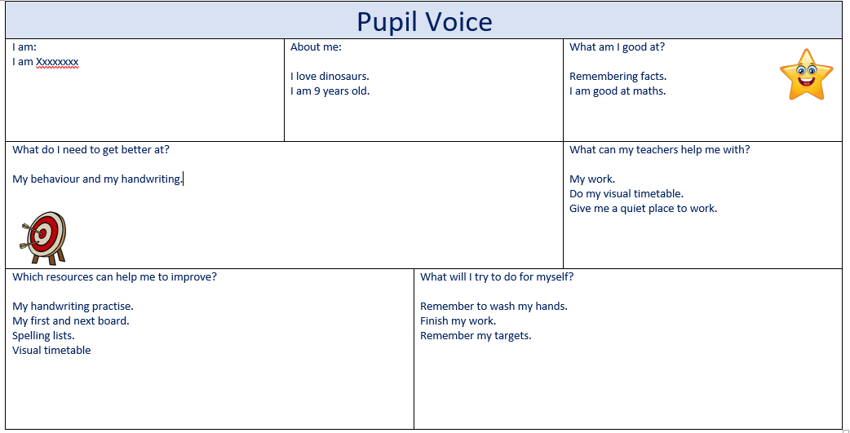

Children with an EHCP are involved in their annual review meetings where they are asked their opinions about how they are getting on at school and they are asked if they want to share any information or wishes.
Pupils with Social, Emotional and Mental Health Needs (SEMH) meet with the behaviour or learning mentor each week to evaluate their weekly targets and consider how to achieve these each week. We have widened our provision for supporting pupil with emotional or mental health needs by offering drop-in sessions with the learning mentor.
Engaging pupils in activities with their peers
All break time and lunchtime activities are open to children with SEND and reasonable adjustments will always be made to help them to participate.
Children with SEND are encouraged to work alongside their peers to develop their speaking and listening skills and social skills. This is done as part of normal practice within the classroom or during intervention groups.
Supporting social and emotional development and wellbeing
The school takes pride in its friendly and positive ethos. Clear and well-established behaviour policies help all pupils to achieve their best. Sometimes, a child needs to have behaviour targets included their PLP. We work closely and co-operatively with parents to address any issues.
We have a pastoral team made up of a learning mentor and a behaviour support worker who support children by mentoring them on any issues they may have regarding behaviour, social or emotional factors. This is done either on a one to one basis or in a small group. Pastoral groups are delivered on a range of themes to support children with SEMH difficulties including friendship skills, managing anger, recognising emotions and developing social skills. The groups are assessed and reviewed each term by teachers, the SENDCo, behaviour support worker and learning mentor.
SEND pupil interviews and questionnaires happen each year at Holybrook to ensure that these children have the chance to express their views about their education and the school. We have a school council in school and children have the opportunity to make suggestions to their class members to take to school council meetings.
In 2021, the school launched the Zones of Regulation tool across the school. This was because we recognised that many pupils might be experiencing emotional or mental health difficulties as a result of the Coronavirus lockdown. Children are now learning the skills of self-regulation and are developing their toolkits of support to use when they are feeling sad, angry or anxious.
Supporting children through transition
Holybrook has robust procedures for ensuring a smooth transition for pupils either starting at our school or moving on to another educational setting.
For children moving on, including those in Year 6, the SENDCo arranges transition meetings with the receiving school to ensure that all relevant information is shared and to promote the continuity of curriculum provision. Where a child has complex needs and is potentially changing settings including more specialist provisions, we can accompany the child and parents on visits to possible schools to consider provision and preferences.
At EHCP reviews in Years 5 and 6, transition to secondary school is discussed and preferences are written into the review, and where possible and appropriate, secondary school staff are invited to attend.
Equally, if a child with SEND is transitioning to Holybrook from a different setting, the SENDCo will liaise closely with the setting, ensuring the smooth transfer of information so that the correct curriculum provision is in place for the child when they start with us. Such transition arrangements could include the SENDCo and other Holybrook staff visiting the child in their current setting and meeting with staff and parents to gather information.
Some of our pupils with Social, Emotional or Mental Health (SEMH) difficulties and who have EHCPs, might get the opportunity to transition to our Horizons Resourced Provision. When this is the case, transition is carefully planned so that we can ensure that the child feels secure as they change settings.
Horizons
In the 2020-21 academic year, our Horizons centre has successfully transitioned from a turnaround centre to an SEMH Resourced Provision. Over the year, pupil numbers have been steadily increasing with pupils from both Holybrook and other schools across Bradford and it is hope that it will reach its full capacity of 16 pupils in 2021-22. We have recruited Carly Waerea as centre leader and SENDCo and she has overseen all aspects of pupil transition since starting in January 2021.
Training
Training in SEND forms part of the continuing professional development planned for all staff. This includes staff meetings and training days. Other training for individual members of staff or groups of staff is provided according to identified individual need.
The SENDCo keeps up-to-date with local and national developments and attends meetings half-termly with the Exceed SENDCo network to discuss this. Bradford SENDCo Network meetings run by Bradford LA are also attended.
Class teachers need an in-depth knowledge to assist children in their class. If training for a particular need is identified or recommended, the class teacher will attend this to support their teaching and understanding of the needs of their children.
Teaching assistants need support in delivering appropriate curriculum interventions for individuals or groups in their class. If a new curriculum intervention is to be run, we will ensure that these teaching assistants are well trained and confident with the intervention before they start delivering it. Professional development is very important and it ensures that all adults are well equipped to manage and support the needs of the children they work with.
In 2020-21, all staff have received training on interventions such as Precision Teaching and the Zones of Regulation which have benefited our SEND pupils.
The SENDCo also acts as link to a wide range of other specialist agencies, such as Speech and Language Therapy, Bradford’s SEND Support Services, CAMHS, Educational Psychology, School Health, Hospital Paediatrics, Physiotherapy and Occupational Therapy, Hearing and Visually Impaired Services, and parent advice groups such as ones available through Early Help.
Accessing other agencies and provision
Services can become involved by school referral, referral by other agencies, or directly by parental request. In all cases (except some where there may be issues of child protection) referrals require parental permission. The support given may be assessment, advice, or direct input. We ensure that provision is given to all children who require it. Equipment and provision is ordered according to identified need to ensure best access to the curriculum. Most of this is purchased through school funding. At times we may borrow specialist equipment from support services involved.
Admissions
All admissions are in accordance with the school’s Admission Policy which follows Bradford LEA’s Admission processes. If a child has an Education, Health and Care Plan, the local authority consults with schools and parents before agreeing a placement. If a child has significant needs but no EHCP, the standard admissions process applies. Successful integration into a new school often depends on thorough planning. We welcome early contact from parents so that we can discuss needs, and anticipate and plan to overcome any potential barriers before the child arrives in school.
How do parents voice concerns?
Most concerns are resolved readily and informally by discussion with the teacher. If not, a matter may be escalated to the SENDCo and the Head of School. Beyond this, a complaint may be taken to the Governing Body using the complaints procedure.
School’s local offer
This is a detailed document which lists the support provided for each area of need at each level of SEND.
It can be found on the school’s website using this link:
SEND Local Offer | Holybrook Primary School (holybrookacademy.co.uk)
Information about Bradford Council’s SEND offer can be found here: https://localoffer.bradford.gov.uk/
Accessibility Plan
The school’s accessibility plan can be found on the school website.
https://holybrookacademy.co.uk/wp-content/uploads/2018/10/Accessibility-Plan-HB.pdf

Contact details
Joanna Jackson – Deputy Head and SENDCo
Carly Waerea – Horizons Centre Leader and SENDCo
Chris Lloyd – Head of School
Christabel Shepherd – Executive Head Teacher
Tel: 01274 611327
Email: office@holybrookacademy.co.uk

